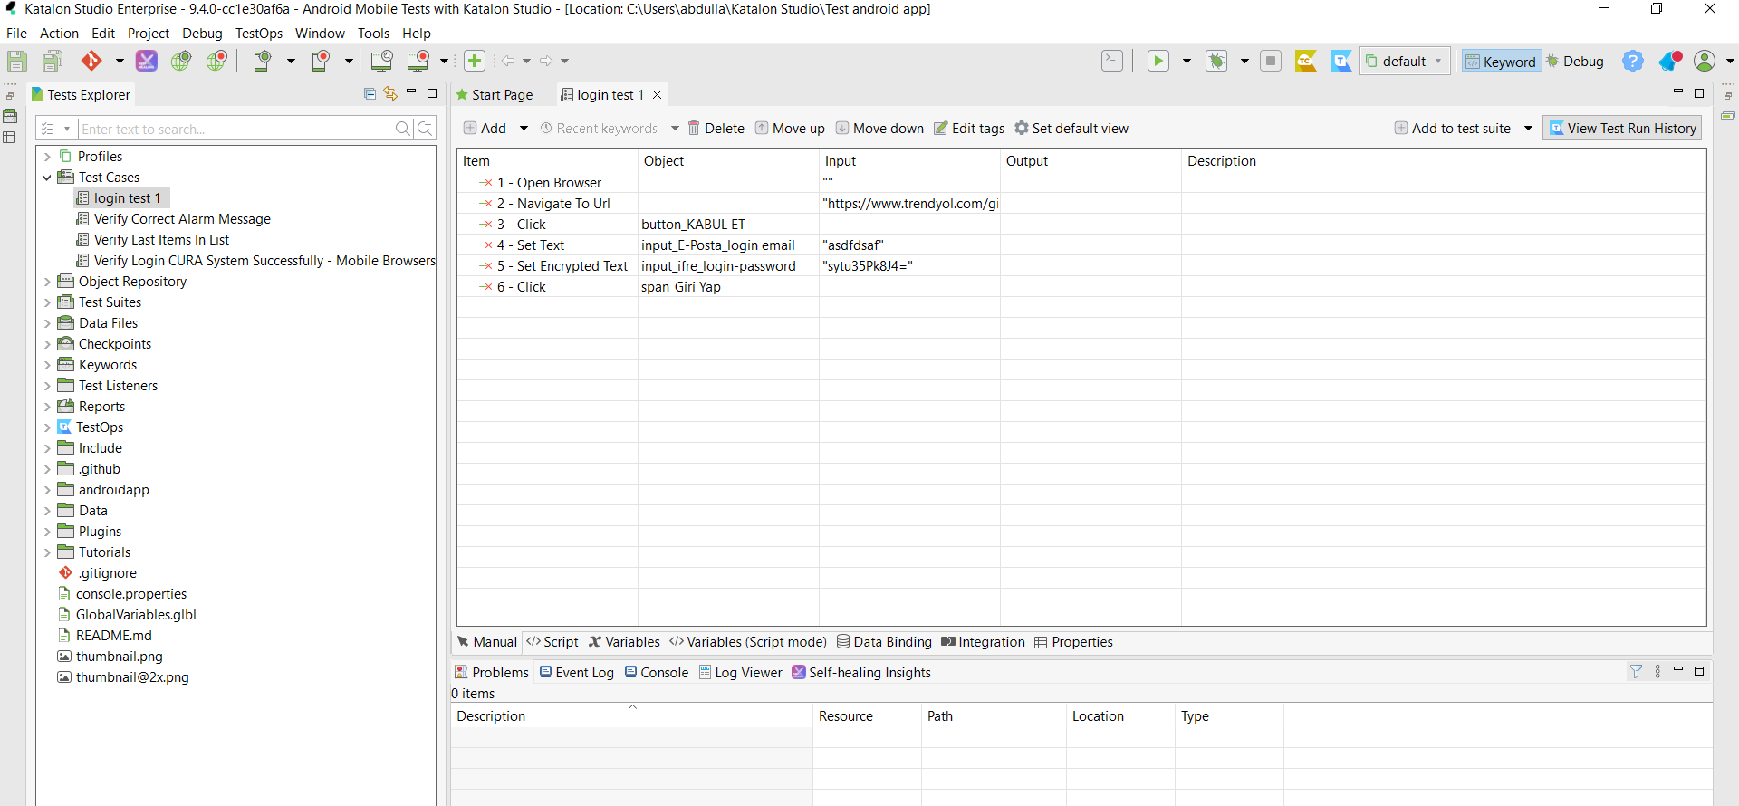  
  
I downloaded katalon and created a new project. Created a new test case and tried to log into trendyol.  
  
